|  | INTERNATIONAL TELECOMMUNICATION UNION  **TELECOMMUNICATION** **STANDARDIZATION SECTOR**  STUDY PERIOD 2022-2024 | | **Focus Group on AI Native Networks** | |
| --- | --- | --- | --- | --- |
| **AINN-I-xx** | |
| **Original: English** | |
| **Question(s):** | | N/A | Virtual, TBD 2024 | |
| **INPUT DOCUMENT** | | | | |
| **Source:** | | *Avengers Pvt. Ltd* | | |
| **Title:** | | *Hack-avengers - Report on* *ITU WTSA Hackathon 2024 – Network outage while the “Hit man” is batting.* | | |
| **Contact:** | | Mr. Rohith | | E-mail: name@gmail.com |

| **Abstract:** | This document contains the submission of a report for Hack-avengers towards ITU WTSA Hackathon 2024 for use case *Network outage while the “Hit man” is batting.* |
| --- | --- |

## Use case introduction**: “Network outage while the “Hit man” is bating”**

It was the IPL finals, and the entire city was buzzing with excitement. The stadium was packed, and everyone, from fans in the stands to those watching on giant screens outside, was capturing every moment. **Phones were flashing**, **videos were being recorded**, and **pictures were instantly shared with friends and family**.

An unexpected **network outage** occurs. Panic situation in the crowd, as messages and pictures failed to send.

Consider the scene map below:

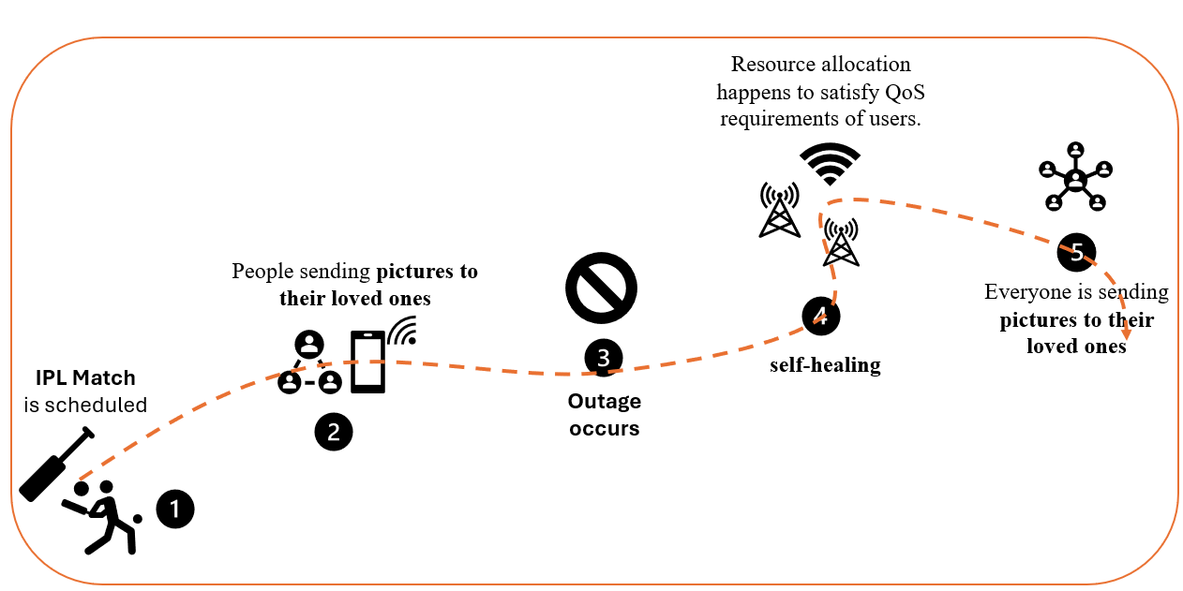

Phase 1: IPL Match is happening.

Phase 2: Everyone is sending pictures to their loved ones.

Phase 3: Outage happens and small base station deployed (femtocells).

Phase 4: self-healing using femto base station.

Phase 5: Resource allocation happens to satisfy QoS requirements of users.

Phase 6: Everyone is sending pictures to their loved ones.

Clause-2: use case requirements

Clause-3: PS1: pipeline design

* AI /ML Concept used is event analysis and anomaly detection

Clause-4: PS2: xApp design

* Open RAN concept used is self-healing.

Clause-5: Relation to Standards.

Clause-6: Code submission details

Clause-7: Self-Testing results

_________________